







**PROJECT: 4th Industrial Revolution**

\

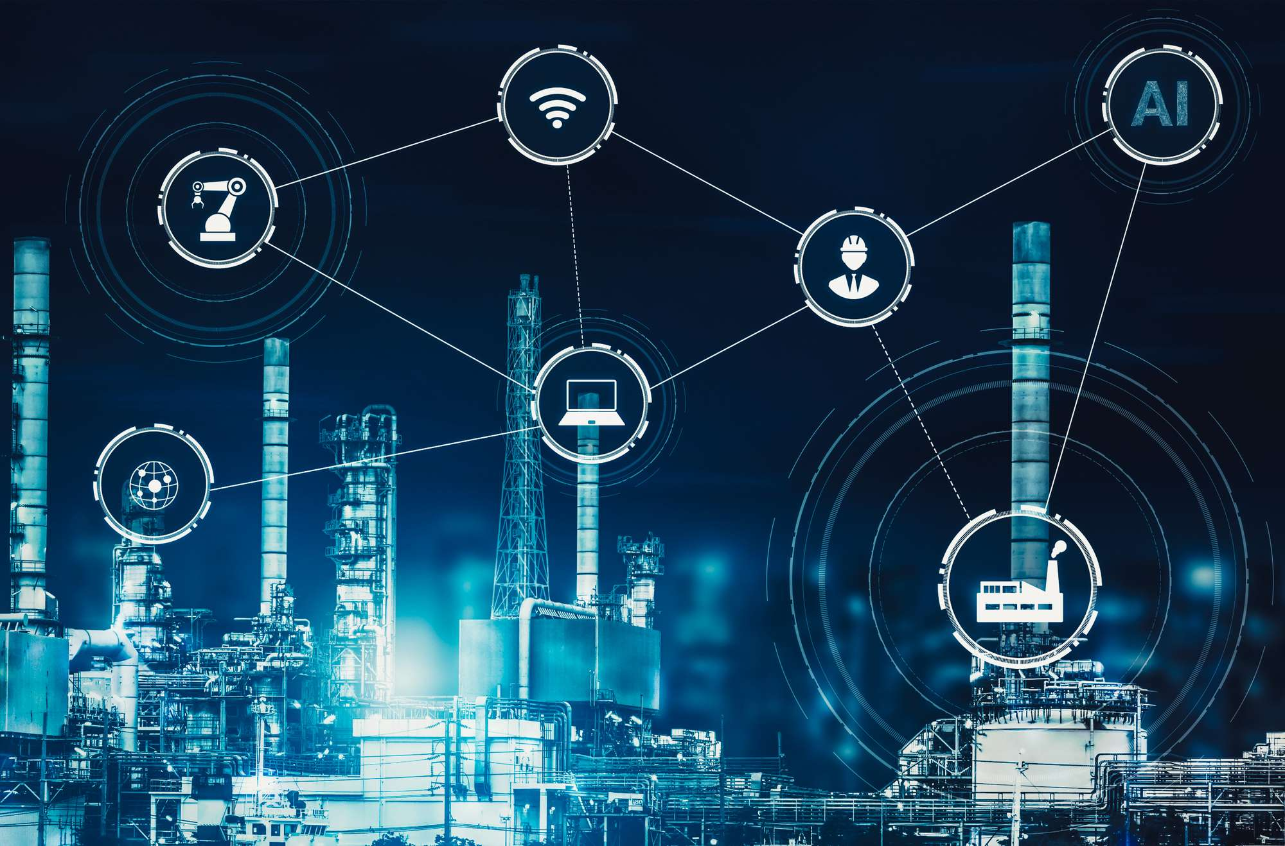

Enhancing Digital Government & Economy (EDGE) Project

Bangladesh Computer Council (BCC) Information and Communication

Technology Division Ministry of Posts, Telecommunications, and

Information Technology Government of the People's Republic of

Bangladesh

And

Center for Digital Transformation (CDT)

Begum Rokeya University, Rangpur

Rangpur-5404, Bangladesh

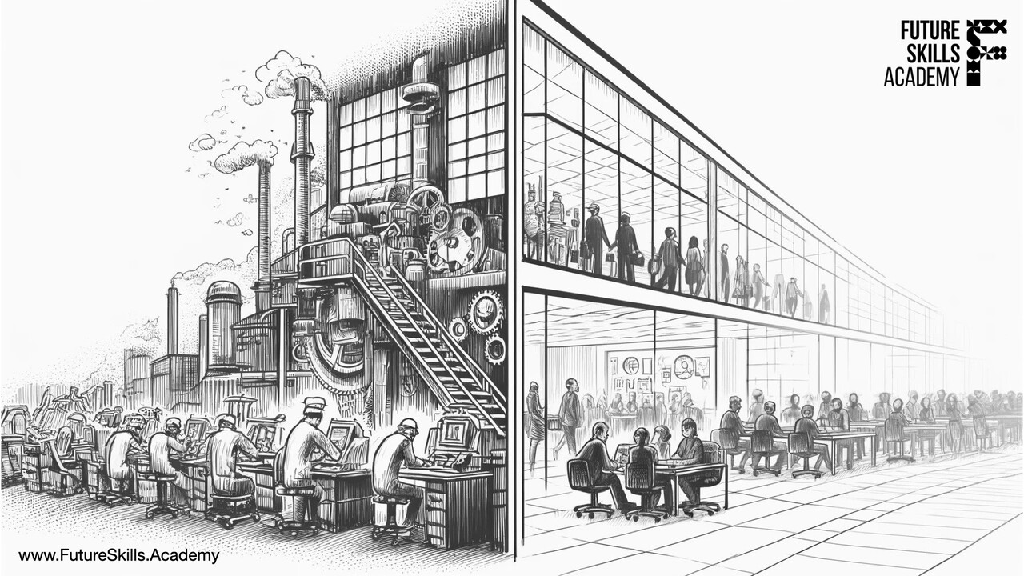

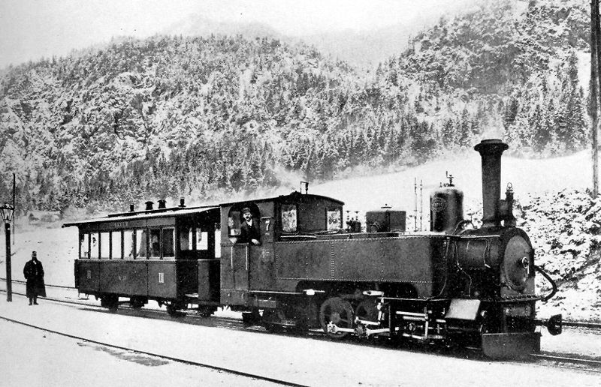

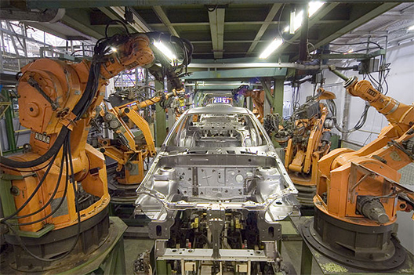

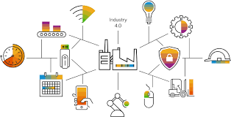

\

ABU-HANIF

Batch:27 ; SL No: 06

Submitted by:









Enhancing Digital Government & Economy (EDGE) Project

Bangladesh Computer Council (BCC) Information and Communication

Technology Division Ministry of Posts, Telecommunications, and

Information Technology Government of the People's Republic of

Bangladesh

And

Center for Digital Transformation (CDT)

Begum Rokeya University, Rangpur

Rangpur-5404, Bangladesh

Project Title :

4th Industrial Revolution

|  |  |
| --- | --- |
| Name | :Abu -Hanif |
| S.L | : 06 |
| Batch No | :27 |

Special Thanks

Special thanks to our course instructors for continuous support and encouragement

Special

Dedication

This research project is dedicated to my parents , my classmate and my basic computer course instructors for the support, love and understanding.

ACKNOWLEDGEMENT

I would like to express my sincere gratitude to all those who contributed to my understanding of the Fourth Industrial Revolution. This transformative era, characterized by the convergence of advanced technologies such as artificial intelligence, robotics, the Internet of Things, and biotechnology, would not be comprehensible without the guidance and resources provided throughout the course.

Special thanks to our instructor, whose expertise and passion for the subject have inspired me. Their insights and encouragement pushed me to delve deeper into the implications of these technologies on society, the economy, and the workforce. I also appreciate the camaraderie and collaborative spirit fostered among my peers, which enriched our discussions and enhanced our collective learning experience.

Additionally, the various case studies and practical examples presented in the course have significantly shaped my perspective on how industries are evolving and adapting to these rapid changes. I am grateful for the opportunity to engage with thought leaders and experts in the field, which further expanded my knowledge and understanding.

Lastly, I acknowledge the importance of continuous learning in navigating this ongoing revolution. I am excited to apply the concepts and insights gained from this course as I move forward in my studies and future endeavors.

Thank you all for your support and encouragement along this journey.

Sincerely,

_________________

[ABU-HANIF]

[Date: 17/01/2025]



Table of Contents

1 Introduction 7

2 History of Industrial Revolutions 7

2.1 1st Industrial Revolution 7

2.2 2nd Industrial Revolution 8

**2.3 3rd Industrial Revolution …………………………………………………………………………………………….8**

**2.4 4th Industrial Revolution ……………………………………………………………………………………………. 8**

3 4th Industrial Revolution Technologies 9

3.1 Artificial intelligence: 9

3.2 Autonomous vehicle 11

4 *Contribution of Apparel industries in the economy of Bangladesh* 14

5. Impact of Industry 4.0 in Bangladesh apparel sector 16

6 RESULTS AND DISCUSSION: 17

6.1 Governance system in the upcoming decade 17

6.2 Inequality forced by this new production system 18

7 POLICY IMPLICATION: 21

8 Conclusion 22

10 References 25

# 1 Introduction

The industry 4.0 concept is first presented by the German Federal Government in 2011 and a roadmap was released in 2013. It refers to the intelligent networking of machinery and processes for industry with the help of information and communication technology. It is basically a combination of using artificial. intelligence, automation in production process, using programming language for required software applications, such as integrated Enterprise Resource Planning ERP) system, Manufacturing Execution System(MES). Systems Applications and Products (SAP), Microsoft Project Management (MPM), Product lifecycle management (PLM), Supply chain management (SCM). Forecasting productivity data, etc. use of internet, 3D printing. Data furcating, trouble shooting and so on. The main supporting industry 4.0 are autonomous robots, industrial internet of things (ПоТ), large data and analytics, imitation/digital matching, enlarged reality, additive manufacturing, cyber security, cloud computing, horizontal and perpendicular system integration, etc. It gives such an environment where automation is used for increasing the productivity with less no. of defects, finding the optimum production process, data analyzing, problem-solving, less no. of human required. and maintains effective backward and forward linkage, better human resource managements, etc. However, the prime goal of IR 4.0 is to fulfill the specific customer requirements which affect zones such as managing the orders, product research, and development, industrial set up, distribution up to the usage and reuse of products . The basic-variance between IR 4.0 and Computer Integrated Manufacturing (CIM) is the human role in the manufacturing environment. Industry 4.0 has significant roles of human workers in execution the production whereas computer integrated manufacturing considered eliminating workers in manufacture . The drawbacks of IR 4.0 are Inequality which means trained employees will get more facilities than others; Cybersecurity risk iratest risk of hacking and tampering data, Core industries disruptions i.e., systematic development of industries will not occur as Traditional television and cinema compete with Netflix and YouTube, and Ethical issues, etc. The target of this review is to study the impact of IR 4.0 in Bangladesh Apparel Industrial. (A. N. M. Ahmed Ullah, Review on Industry 4.0 and Challenges of Implementation in Garment Industries of Bangladesh, July 2021)

# 2 History of Industrial Revolution

The world has passed and humanity has evolved through 5 identified industrial revolutions. Each of the revolution brings significant changes to the society, economy and to the world itself.

## 2.1 1st Industrial Revolution

|  |  |
| --- | --- |
| The 1st one came with the mechanization of steam power, the first mechanical loom driven with steam power came in to play in 1784. It was the beginning of utilization of converted energy for production. |  |

### 2.2 2nd Industrial Revolution

|  |  |
| --- | --- |
| The 2nd revolution triggered by the requirement of mass production, which was met by decisioning of labor and introducing production line powering by electricity. The first assembly line was used in Cincinnati Slaughter House in 1870. |  |

#### 2.3 3rd Industrial Revolution

|  |  |
| --- | --- |
| The 3rd revolution somewhat is still ongoing thorough computerization, digital transformation and automation. But it is considered has begun in 1969 with first Programmable Logic Controller(PLC). |  |

##### 2.4 4th Industrial Revolution

|  |  |
| --- | --- |
| Industry 4.0 allows for smart manufacturing and the creation of intelligent factories.  .It aims to enhance productivity, efficiency, and flexibility while enabling more intelligent decision-making and customization in manufacturing and supply chain operations. |  |

Currently, there is a great deal of discussion being conducted in various countries regarding the “Fifth Industrial Revolution,” which follows on from the Fourth Industrial Revolution. The Fifth Industrial Revolution incorporates concepts such as “sustainability,” “human-centeredness,” and “concern for the environment” in addition to transformation of the industrial structure through the utilization of AI, IoT, big data, etc., which was debated in the Fourth Industrial Revolution

|  |  |
| --- | --- |
| In 1969, the third industrial or digital uprising presented and advanced the individual computer, and the internet led to the democratization of evidence, price reductions, and fast quality enhancement, signaling a new age of entrepreneurship; reforming the economic structure, and making calculation easier for businesses and government. In addition, the industry 4.0 discusses the workplace digitalization and automation, which will profoundly alter working conditions, economic practices, and cultural phenomena in the future decades . |  |

In Bangladesh, the impact of the industrial revolution was seen during the last three centuries where traditional boats were suppressed by motor boats and steamers, type writers to computers, hand spinning to machine spinning, handlooms converted to power looms, Hand sewing to higher speed sewing machinery of garments and so on. Figure 1 shows the sequential industrial revolutions of the world. (A. N. M. Ahmed Ullah, Review on Industry 4.0 and Challenges of Implementation in Garment Industries of Bangladesh, July 2021)

# 3 4th Industrial Revolution Technologies

## 3.1 Artificial intelligence:

Artificial intelligence (Al) is the ability of a digital computer or computer-controlled robot to perform tasks commonly associated with intelligent beings.

|  |  |
| --- | --- |
|  | The term is frequently applied to the project of developing systems endowed with the intellectual processes characteristic of humans, such as the ability to reason, discover meaning, generalize, or learn from past experience. Since the development of the digital computer in the 1940s, it has been demonstrated that computers can be programmed to carry out very complex tasks-as, for example, discovering proofs for mathematical theorems or playing chess with great proficiency |

Still, despite continuing advances in computer processing speed and memory capacity, there are as yet no programs that can match human flexibility over wider domains or in tasks requiring much everyday knowledge. On the other hand, some programs have attained the performance levels of human experts and professionals in performing certain specific tasks, so that artificial intelligence in this limited sense is found in applications as diverse as medical diagnosis, computer search engines, and voice or handwriting recognition.

What is Intelligence?

|  |  |
| --- | --- |
| All but the simplest human behavior is ascribed to intelligence, while even the most complicated insect behavior is never taken. as an indication of intelligence, Intelligence must include the ability to adapt to new circumstances.  Psychologists generally do not characterize human intelligence by just one trait but by the combination of many diverse abilities. Research in Al has focused chiefly on the following components of intelligence: |  |

1.Reasoning

To reason is to draw inferences appropriate to the situation, Inferences are classified as either deductive or inductive, there has been considerable success in programming computers to draw inferences, especially deductive inferences, However, true reasoning involves more than just drawing inferences; it involves drawing inferences relevant to the solution of the particular task or situation. This is one of the hardest problems.

2. Problem solving

Problem solving, particularly in artificial intelligence, may be characterized as a systematic search through a range of possible actions in order to reach some predefined goal or solution. Problem-solving methods divide into special purpose and general purpose. A special-purpose method is tailor-made for a particular problem and often exploits very specific features of the situation in which the problem is embedded. In contrast, a general-purpose method is applicable to a wide variety of problems. One general-purpose technique used in Al is means-end analysis a step-by-step, or incremental, reduction of the difference between the current state and the final goal. Many diverse problems have been solved by artificial intelligence programs. Some examples are finding the winning move (or sequence of moves) in a board game, devising mathematical proofs, and manipulating "virtual objects" in a computer-generated world.

3. Perception

In perception the environment is scanned by means of various sensory organs, real or artificial, and the scene is decomposed into separate objects in various spatial relationships. Analysis is complicated by the fact that an object may appear different depending on the angle from which it is viewed, the direction and intensity of Illumination in the scene, and how much the object contrasts with the surrounding field.

At present, artificial perception is sufficiently well advanced to enable optical sensors to identify individuals, autonomous vehicles to drive at moderate speeds on the open road, and robots to roam through buildings collecting empty soda cans.

4. Language

A language is a system of signs having meaning by convention. In this sense, language need not be confined to the spoken word. Traffic signs, for example, form a mini-language, it being a matter of convention that means "hazard ahead in some countries. It is distinctive of languages that linguistic units possess meaning by convention, and linguistic meaning is very different from what is called natural meaning, exemplified in statements such as "Those clouds mean rain" and "The fall in pressure means the valve is malfunctioning." An important characteristic of full-fledged human languages in contrast to birdcalls and traffic signs is their productivity. A productive language can formulate an unlimited variety of sentences. At present, artificial perception is sufficiently well advanced to enable optical sensors to identify individuals, autonomous vehicles to drive at moderate speeds on the open road, and robots to roam through buildings collecting empty soda cans.

5. Knowledge and inference

The basic components of an expert system are a knowledge base, or KB, and an inference engine. The information to be stored in the KB is obtained by interviewing people who are expert in the area in question. The interviewer, or knowledge engineer, organizes the information elicited from the experts into a collection of rules, typically of an "if-then" structure. (Employment, Autonomous vehicle Prepared By - Begum Suhana Islam, Senior Assistant Secretary Ministry of Labour and Employment, 2021)

### 3.2 Autonomous vehicle

We are moving towards an age of autonomous vehicles. This is not an overnight development; but has been ongoing for decades. The vision for autonomous vehicles is ambitious and compelling. It may sound like science fiction rather than a real development that could happen in our lifetimes. Yet, the possibility exists that we will see fully autonomous vehicles on roads in a scant few decades (or years). A radical reduction in the number of fatalities, injuries, and property damage due to crashes is a huge motivating factor in the realization of the autonomous vehicle. According to National Highway Traffic Safety Administration of U.S, Motor vehicle crashes are the leading cause of death for ages 11-27, and over 32,000 people are killed each year in crashes. Additionally, there are over two million crashes with injuries and over three million crashes with property damage. On average, one person is killed every 16 minutes in a vehicle crash, Moreover, crash causation studies reveal that 93% of all crashes are attributable to driver error. Hence, the development of artificial intelligence and real-time data processing technologies have enabled the introduction of autonomous vehicles as a revolutionary concept for future days.

What is an autonomous vehicle?

(AVs), also known as self-driving cars or driverless cars are vehicles that can drive without the

|  |  |
| --- | --- |
|  | aid of a human operator. An autonomous vehicle, or a driverless vehicle, is one that is able to operate itself and perform necessary functions without any human intervention, through ability to sense its surroundings, An autonomous vehicle utilizes a fully automated driving system in order to allow the vehicle to respond to extremal conditions that a human driver would manage |

6 Levels of Autonomous Vehicles

There are six different levels of automation and, as the levels increase, the extent of the driverless car's independence regarding operation control increases.

At level 0, the car has no control over its operation and the human driver does all of the driving.

At level 1, the vehicle's ADAS (advanced driver assistance system) has the ability to support the driver with either steering or accelerating and braking.

At level 2, the ADAS can oversee steering and accelerating and braking in some conditions, although the human driver is required to continue paying complete attention to the driving environment throughout the journey, while also performing the remainder of the necessary tasks.

At level 3, the ADS (advanced driving system) can perform all parts of the driving task in some conditions, but the human driver is required to be able to regain control when requested to do so by the ADS, In the remaining conditions, the human driver executes the necessary tasks.

At level 4, the vehicle's ADS is able to perform all driving tasks independently in certain conditions in which human attention is not required.

Finally, level 5 involves full automation whereby the vehicle's ADS is able to perform all tasks in all conditions, and no driving assistance is required from the human driver. This full automation will be enabled by the application of 5G technology, which will allow vehicles to communicate not just with one another, but also with traffic lights, signage and even the roads themselves.

Currently, vehicles are only partly autonomous (level 2). capable of, for instance, autonomous parking. However, vahine companies, including Ford, Honda, Toyota, Nissan, Volvo, Hyundai, Daimler, Fiat-Chrysler, and BMW increase investments in the development of autonomous vehicles

One of the aspects of the vehicle technology used in automated vehicles is ACC, or adaptive cruise control.

This system is able to adjust the vehicle's speed automatically to ensure that it maintains a safe distance from the vehicles in front of it. This function relies on information obtained using sensors on the vehicle and allows the car to perform tasks such as brake when it senses that it is approaching any vehicles ahead. This information is then processed and the appropriate instructions are sent to actuators in the vehicle, which control the responsive actions of the car such as steering, acceleration and braking. Highly automated vehicles with fully automated speed control are able to respond to signals from traffic lights and other such non-vehicular activities,

Basic Physical Ecosystem of an Autonomous Vehicle

|  |  |
| --- | --- |
|  | * Global Positioning System (GPS) * Light Detection and Ranging (LIDAR) * Cameras (Video) * Ultrasonic Sensors * Central Computer * Radar Sensors * Dedicated Short-Range Communications-Based Receiver |

What are the Advantages?

Autonomous vehicle technology may be able to provide certain advantages compared to human-driven vehicles. One such potential advantage is that they could provide increased safety on the road-vehicle crashes cause many deaths every year, and automated vehicles could potentially decrease the number of casualties as the software used in them is likely to make fewer errors in comparison to humans which is the cause of 93% crashes in the U.S. Secondly, due to better route planning and more efficient operation, AVs are predicted to reduce road congestion by the removal of human behaviors that cause blockages on the road. It reduces fuel emission and fuel economy as well as improve pavement stability Thirdly, what may be important for consumers is the ability of AVs to save time and Another possible advantage of automated driving is that people who are not able to drive-due to factors like age and disabilities-could be able to use automated cars as more convenient transport systems, Additional advantages that come with an autonomous car are elimination of driving fatigue and being able to sleep during overnight journeys.

Challenges of Autonomous vehicles:

Introduction of AVs is connected with multiple challenges such as safety, legal liability, ethical questions, personal injury, Cybersecurity and data breaches, intellectual property ownership and regulatory issues, which result in consumers' fear towards this tech, AVs also are a challenge to the traditional role of drivers and driving pleasure. Even though the benefits of AVs seem to significantly outweigh the risks associated with them, consumer acceptance of this technology is still uncertain. It is, however, crucial for its diffusion and commercial success. While many studies concerning attitudes towards AVs were conducted, the results are mixed, some found that the positive attitude prevails, while other show the contrary.

Some recent developments on Autonomous vehicle:

In, January 2017 Keolis and NAVYA, in partnership with the city of Las Vegas, launched the first autonomous, fully electric shuttle to be deployed on a public roadway in the United States, January 2018- Toyota announces "e-Palette' concept vehicle which is a fully electric autonomous vehicle that can be customized by a partner for applications such as food deliveries (Pizza Hut), ride-sharing (Uber), or store fronts (Amazon), January 2018-Udelv, a Bay Area tech company, completed the first delivery of goods by a self-driving car when it delivered groceries in San Mateo, February 2018-Hyundai announced that a fleet of its fuel cell electric cars made a successful fully automated trip from Seoul to Pyeongchang. This is the first time a Level 4 car has been operated with fuel cell electric cars. It is estimated that 10 million autonomous vehicles will hit the roads by 2022. In 10 years fully autonomous vehicles will be the norm. AVs will generate a $7 trillion annual revenue stream by 2050. Widespread adoption of AVs could lead to a 90% reduction in vehicle crashes, (Employment, Autonomous vehicle Prepared By - Begum Suhana Islam, Senior Assistant Secretary Ministry of Labour and Employment, 2021)

# 4 Contribution of Apparel industries in the economy of Bangladesh

Since 1980, the Ready-Made Garment. (RMG) sector plays a critical part in Bangladesh's socioeconomic development. [14]. In an annual survey, the industries of Bangladesh show that manufacturing is dominated by 96.5% of all industries while 86% of them are garments products and again more than 80% of foreign currency earning sector of Bangladesh. Approx. 5000 garments industries are located in Bangladesh and 4.4 million people are working there. Bangladesh enjoys Generalized System of Preferences

(GSP) facilities for the apparel zone to Japan, Australia, New Zealand European Union (EU), Canada, and several duty-free market places get right of entry to China, South Korea, India, and Asia Pacific Trade Agreement (APTA) scheme for China, South Korea.

Nowadays excessive value-added clothing production is on the rise in our country. There is an indication of a continuous quality increase in Knit & Woven garments export from Bangladesh. Not only the RMG products but also its supportive backward and forward. linkage enterprise such as apparel accessories industries, varied jute items manufacturing industry, packaging industry also earns foreign currencies which make contributions in the export zone of Bangladesh. Figure 2 shows the strengths of the apparel industries in Bangladesh, e.g. competitive price, experience, commitment, safety, workforce, and so on.

Figure 2: The strengths of the apparel industries in Bangladesh (Courtesy - BGMEA).

Figure 3 shows the increasing trend of the export of readymade garments from Bangladesh.

Figure 4: The percentages of RMG's to total export of Bangladesh from 1983-84 to 2020-2021.

From figure 4, it is seen that the export percentage of RMG to the total export of Bangladesh is increased from 1983-84 to 2020- 2021. It is clearly observed that the export percentage of garments holds the major portion of the total export of the country (Courtesy- BGMEA).

supports and corruption, integrating and establishing industry 4.0 is complicated. Without rehabilitation of huge women-workers will be a social reform which in turn may be backfired. So, to choose the issue as it is the most vital sector of Bangladesh. dominancy of IR.

It is observed from figure 5th at the apparel export is emerging since 1992-93to till now (Courtesy-BGMEA). (A. N. M. Ahmed Ullah, Review on Industry 4.0 and Challenges of Implementation in Garment Industries of Bangladesh, 2, July 2021)

# 5. Impact of Industry 4.0 in Bangladesh apparel sector

Bangladesh is now under the challenges of the 21" century global business environment. On the basis of the current scenario, the application of IR 4.0 in Bangladesh garment. industries have to face some significant challenges such as: Garments business is very much competitive, cope up with the global market changing situation, minimize the cost with proper quality products, improve customer satisfaction, poor infrastructure like roads, uninterrupted electricity, the convenience of economy technical labor, costly installation of modern technologies, absence of government 400will certainly be harmful to the economy, without the development of human resources, sensitive labor policies, and job-based education may be some of the challenges. anticipated in the economy of Bangladesh.

However, there are some advantages of automation in apparel industries, e.g. shorter lead time, enhanced quality of the products, increase productivity, minimize human, and maximize work, more efficiency, less floor space, etc. Automation has already been introduced in some garments industries in different sections like cutting auto cutting machine, auto fabric spreader, computer-aided manufacturing, auto arm cutting, laser cutting machine, etc. In sewing section zigzag stitch, cuff, collar, j-stitch, zipper, garbage to reduce main stitching line operation, cycle check machine can sew some of the particular area

speedy, embroidery machine with automation. These machineries have integrated computerized intelligence system which can operate according to commands.

Emerges Technique CAD, CAM system can improve and minimize the functions. ERP software may minimize the manpower. Artificial intelligence and 3D modeling technique in particular have gained popularity. In the beginning, it was just garments creation and testing the fit, but now also it is design and selling contribute to faster and more effective decisions, small carbon footprint and less fabric waste, sustainability, saving, energy and

Bangladesh is the house of the highest number of green factories (highest numbers are Leadership in Energy and Environmental Design (LEED) certified which enhances with the careful images to be a sustainable partner in the globe. The technologies now emerging, of course have to the capacity to develop the apparel industry on its top. But for the implementation, the industry needs a more skilled workforce knowledge. (A. N. M. Ahmed Ullah, Review on Industry 4.0 and Challenges of Implementation in Garment Industries of Bangladesh, 2, July 2021, )

# 6 Results and Discussion

Bangladesh is trying to raise awareness among the stakeholders about the FIR concept and encourage entrepreneurs to incorporate new technologies to get benefits from it. However, this transformation process towards FIR will create both positive and negative impacts in different sectors. Experts predicted five crucial sectors that needed to be focused by the government to take adaptation policies while going through this transformation. These sectors are briefly discussed below-

## 6.1 Governance system in the upcoming decade

FIR will create an opportunity to adopt innovations in political systems. The pattern of vote casting, election time violence, as well as the political manifesto of the political parties, will be changed. Digital platforms will be used for election campaigning, and intelligent voting systems will be introduced. The country will move into a new administrative paradigm called the future digital e-governance system. According to Md. Anique Rahman, Department of International Relations, University of Dhaka (personal communication, January 20, 2020), "The manifesto of the government will be centralized to digital development, and there will be a paradigm shift of the administrative system from New Public Service to the future e-governance."

Democracy will face a lot of challenges in the upcoming decade. The demand of the people will be changed, and political leaders will need new ideologies to tackle the modern social complexities under the FIR. Political polarization will be so evident in national politics, which will create an extreme environment in the political arena. Due to the domination of capitalists in the political system, anti- government populism will rise, and that will drive the mass population towards movement against capitalist systems. As per an interview with a senior professor of Dhaka University, "Acute social and economic inequality will force people to raise their voice to fulfill their demand, leading to resurrect socialism in Bangladesh" (M. Nuruzzaman, personal communication, January 22, 2020).

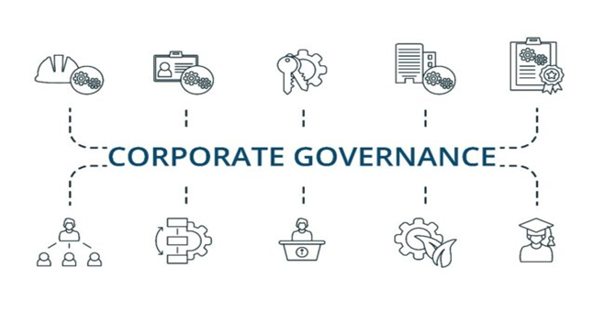

Automation in the service delivery system will make the public service more available for the citizens and ensure transparency in the working procedure of the government. Massive public sector reform will take place, and maintaining this transformation will be a tremendous challenge for the political leaders. Hence some radical change is brought under the govern- mint’s flagship A21 program to make the government sector versatile, efficient, and competitive. For example, 4,554 Union Digital Centers, more than 100 streamlined public services, e-procurement, and smart health cards are moving Bangladesh along the FIR track (World Economic Forum, 2018, Rashid, 2020). According to the prediction of a professor of political science, FIR will help citizens to participate in governments policymaking and reduce the communication gap between the government and citizens (N. Parvin, personal communication, January 20, 2020).

### 6.2 Inequality forced by this new production system

Under the new production system, through automation and artificial intelligence, the time and cost of production will reduce, and the benefits of industrialists will increase. However, the labor-based production system will alter with capital-based

techniques, causing dehumanization in the production line (Sun, 2018). In this matter, the president of the Metropolitan Chamber of Commerce and Industry said (Kabir, 2019), "Due to automation, labor market trends will show a gradual shift to jobs that require higher skill levels. New technology does not simply make people redundant; instead, it reduces the labor required for a given level of production. "A lot of people will be jobless. Concurrently, income inequality will rise drastically.

Fig 1: Risk of Automation in job sectors by 2041. Adapted from Finding Emerging Occupations to Tackle the Challenges of Automation in Bangladesh, by ani, august 2019.

According to the Executive Director of RK group of industries (AJ Chowdhury, personal communication, January 20, 2020), "We witnessed a "Digital Divide" during the Third Industrial Revolution, which is about the epoch of ICT. The privileged people who have sagacity in the digital landscape could take on the new jobs. So, if the technology is in the hands of a few wealthy people, then the state of injustice worsens." Most of the respondents reflected the same and supported that statement in their discussion.

As women possess poor knowledge on the technical side, they will face difficulties in the era of FIR (Moktadir, 2018). So, it can be predicted that this revolution will also increase gender discrimination in our country. According to S. Noman (personal communication, January 23, 2020), "Automation will increase gender discrimination, but there is no effective gender-sensitive policy in our country to upskill the women workforce.

As the FIR created social inequality, the general people possess a negative impression about this, where the industrialists are positive because they are the beneficiaries of the FIR. The government is in a policy dilemma as industrialists are the source of finance, and the mass people are considered as vote banks (Gordon, 1981).

#### 6.3 Security concerns under the Fourth Industrial revolution-

FIR will have a crucial impact on state and private security. The security system of the country will be updated with the introduction of robotics in the security forces. The military force will be equipped with Al soldiers. The efficacy of risky operations will be increased by employing bomb disposing of robots, surveillance, and attack drones. According to an associate professor of Jagannath University, "Because of reserving citizens' information on the public server, the crime rate will be reduced by using digital fabrication that helps the government to identify any criminals easily" (N. Mahfuz, personal communication, January 25, 2020).

On the contrary, information is said to be the most powerful weapon if they are in the hand of evil people. Misuse of technological Knowledge will create risk for national security. Moreover, we lack technical experts that force us to hire external experts from abroad, which will decrease the control of the state authority over some sectors. In this issue, an AD of NILG (National Institute of Local Government) opined, "The confidentiality of state policy will be confronted, and the government will lose control in the market because of cryptocurrencies" (M. Imran, personal communication, January 28, 2020).

Domination of Multinational Companies (MNCs) will also be key concern for the government. MNCs collect the personal information of the employees & clients by introducing a biometric registration system and NID card information. In this issue, a Professor of Dhaka University opined. "Technologically developed countries are trying to dominate our economy through MNCs by using our low-cost labor and information" (S. Ahmed, personal communication, January 22, 2020).

##### 6.4 Education and ICT sector change in future

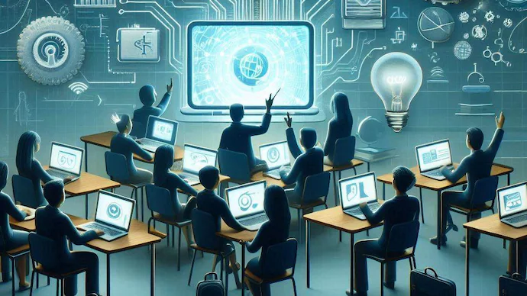

The FIR will bring a major challenge for the education sector as Bangladesh promotes education to its students through didactic pedagogy. A Large scale vocational and practical training program is needed to be integrated with the existing education system. A recent study report shows that 60% in low education, 48% in medium, and 19% in higher education jobs will be displaced by automation (Price water house Coopers, 2018). A lecturer of Jagannath University said, "The education system in Bangladesh is Quantitative rather than qualitative. More focus should be given on STEM to conduct MOOC, Life-long Learning. and Blended instruction, optimization of flipped and online courses, as well as to confer degrees through online. Concurrently, teachers have to focus on flip learning where they teach their students following a UniversePG1 www.universepg.com

different method to prepare the future generation ready for combating the challenge of the 4 industrial revolution." (A. Ehsan, personal communication, January 18, 2020).

To cope with this situation, about 43000 people are given training under the Access to Information (A21) project (A21, 2020), and almost four lakhs’ people get training under the Skills for Employment Investment Program (SEIP) program (Skills for Employment. Investment Program, 2020). Moreover, the government has to focus on different issues to lead the FIR, such as personalization of education (designing for an Indi- visual’s changing needs, unique talents, and interests, an engine for rapid growth, lower costs, and greater profits), specialization of education (advance techno- logical knowledge). About this issue, a lecturer of Independent University, Bangladesh, said. "To facilitate the FIR, skilled workforce and developed infrastructure are needed which can be ensured by proper educational systems. But our country's educational system is quite inverse to the job sectors" (A.Hossain, personal communication, January 18, 2020).

5.5 Global trade structure and future of business in Bangladesh

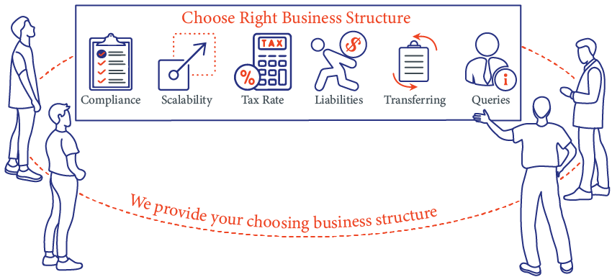

The international community acknownumerous the FIR positively, and they agree that numerous tech companies will dominate the global market in the upcoming period for their intellectual advancement in the field of international trade. At that time, the demand for software will rise. Former VC of Shahjalal University of Science and Technology opined, "The FIR will create new business opportunities like a software business. Bangladesh ranked 2nd in exporting software and expected to expand this business." (M.U.Ahmed, personal communication, January 15, 2020).

Besides this, our indigenous company will have an opportunity to compete with the MNC. Technical capacity and innovation will help them to establish a strong position in their market (Abdin, 2019). As per a senior professor of philosophy, University of Dhaka, "FIR will facilitate the SMEs in online business using new digital landscape, and also they will have to face the domination of MNC as they have more capital." (F. Uddin, personal communication, January 26, 2020).

However, many countries are using technological assistance instead of unskilled labor in their industries.

The demand for labor will decrease, and the capital-oriented countries will adopt a protectionist policy in importing labor. Moreover, it will create an adverse impact in a country like Bangladesh, where foreign currencies by technologically unskilled labor contra- butte 35% of export earnings (Maruf Hasan Rumi', 2020)

# 7 Policy Implication

The FIR is adding significant dimensions in all spheres of the world. It is expected that the stream of the FIR is going to take the top place in Bangladesh in the upcoming decade. This flow will drop a significant impact on national politics and economics. This study has presented that Bangladesh is a little bit prepared to face the changes and challenges of the revolution. The challenges of FIR for a Graduating LDC like us are lack of talented resources, expertise, and better cloud networking, poor infrastructure, huge unskilled population, lack of legal and proper policy support, etc. Alternatively, FIR will bring some positive implications also, with the increase in productivity. sustainable ICT development, women empowerment, citizen empowerment, etc. The adoption of FIR will create significant complexities in our country. This study has revealed that inequality, gender descry amination, unemployment, cyber-crime, the dominance of MNC over SMEs will increase. The most important thing is that the Political system of our country will be influenced in the next decade by the stream of FIR. To minimize the problems and to get benefits from FIR, the government should take effective policies with defined plans at the current period. Despite revealing these results, this study has some limitations like every other research that created a barrier from getting a neutral, practical, and qualitative outcome. The main drawback of this research is that it was time-consuming, and the verification of the result was difficult. It was a labor-intensive study, and the analysis was complex. On the contrary, the findings of this study couldn't be extended to a broader population with the same degree of certainty. Despite these limitations, this study brought a more-clear picture about the impact of the FIR in Bangladesh.

The policies for accepting FIR in our country require it to be based on proper research, and for this purpose. integration of universities in research activities is emergent. This will help to take the appropriate policy and plan for any dramatic situation. In our country, the government takes jumping systems without any research to serve the interest of their political allies, and as a result, this creates difficulties for us. The government should make policies to transfer know- ledge and information to the local industries and to collaborate with educational institutions. To achieve this goal, the private sector should also work along with the government. The private sector should take initiatives to develop and mobilize the skills of human resources according to the demand of the job market of both Bangladesh and other countries. They should also invest in infrastructural development and make a proper strike balance. Finally, it can be concluded that planning should be made in the adjustment or talking period, and the government needs to be anticipatory about the future of the country for becoming a beneficiary of the FIR

# 8 Conclusion

4IR technologies could lead to economic growth and transformation, and improve material welfare, but the impact on the future of work and for youth will depend on policy. Given the wide range of technologies and their impacts, as well as the complex country contexts across Asia, policymakers and stakeholders must do more than count potential job losses and gains. It is crucial for them to look at the potential of 4IR technology holistically, including effects across different social groups, sectors, and, in particular, indirect job creation potential. 41R technologies can help countries return to, and build on, their positive pre-pandemic trajectory by improving productivity and earnings, encouraging the production of new and cheaper products and services, and increasing economic opportunities for youth.

4IR technologies can enable the creation of new employment opportunities across all sectors, providing a wealth of new opportunities that should prove particularly attractive and accessible to Asia's youth. Deployment of 4IR technology could lead to new, often formal, wage jobs being created at a faster rate than the growth of the labor force, and earnings improvements in the informal sector. In the service sector, e-commerce and BPO represent the greatest opportunities for formal wage employment expansion, under the condition that regulatory and infrastructure requirements are met. In agriculture, the 4IR technology can increase earnings, reduce poverty, and have environmental benefits, although agriculture's share of employment will continue to decline with structural transformation. In manufacturing, 4IR technologies may open new opportunities for smaller-scale production for domestic and regional markets, but it is unlikely that it will increase employment due to its inherent labor-saving nature. 4IR technologies may help increase earnings for informal household enterprises. An example of how this could work is mobile money, first adopted by youth, which has improved opportunities within the informal economy, and resulted in increased earnings, savings, and opportunities for women.

The potential of 4IR in each country context depends on policies and investments. Countries must adopt comprehensive strategies that involve public and private sector and international actors and include ministries of youth, employment, technology, finance, infrastructure, and cybersecurity, etc. working together rather than siloing the issue of digital transformation in one body. Key recommendations include improving regulatory and business environments to make them more welcoming of 4IR firms and technology, addressing gaps in infrastructure (energy, broadband, and mobile) and access so all populations, especially rural areas and smaller cities, have reliable internet access and mobile phone service; and developing human capital by reforming education, specifically focusing scarce public resources on foundational skills and basic education rather than costly tertiary education programs that only a small portion of the population can access.

Asia is the world's youngest continent, with a rapidly growing labor force. Youth entering the workforce now face a lack of economic opportunities, made worse by the disruptions to the economy and education brought on by COVID. Despite the economic transformation of the past two decades leading to more wage and salary jobs in the formal sector, the majority of the Asia workforce still works informally, which entails some precarity and risk. While we see potential in 4IR technologies to support the countries to continue and enhance positive pre-COVID-19 economic transformation trajectories, 4IR technology is likely to only bring incremental change in the trajectory of employment transformation, in terms of shift from the informal to the formal sector, as this trajectory has been already set by past demographic change and current level of economic development (AU/OECD, 2021), It is crucial that policy makers recognize that the informal sector will remain strong, and work to improve access to opportunity, including technology, rather

Asia cannot escape 4IR, as Asian states become increasingly integrated into the global economy. The balance between the positive and negative outcomes from 4IR will depend on initial country conditions and policy choices. Despite the number of pages published on 4IR in Asia over the past few years, the way forward seems still muddy in several areas. Asian countries, with more limited resources and infrastructure than many upper-middle-income and high-income countries, will have to develop and try new approaches to address their challenges. Some key questions highlighted above include:

* How can lower-income countries with limited resources expand access to mobile telephone and inter net connections? What is the binding constraint-infrastructure or knowledge? Suggestions offered include auctioning more spectrum and using the funds to subsidize lower-income users, developing programs to support more women using mobile phones and the internet, trying new approaches to expand access in low density areas, etc. But which ones would be most cost-effective, for whom, where, and why?
* How can countries find new financing models for skill development that are equitable and effective? What changes in incentives could the public sector use to encourage universities to look for these opportunities?
* Are investment, R&D, and employment tax incentives worth the fiscal cost in allowing 41R to deliver quality decent jobs for youth in Asia? What are the key drivers of success for such policies? Are they more effective in given countries, regions, sectors than others, or is this irrelevant in the 4IR context?
* How would Asian continental institutions such as the Asian Continental Free Trade Area contribute to shaping Asian digital economies and making 4IR work for decent jobs in Asia? To what ex tent will continual policy harmonization constitute an opportunity or challenge in terms of enabling 4IR quality jobs?

Given the unique and complex nature of the challenges Asia faces in this regard, stakeholders and policy makers would benefit from more case study research at the national level. Authors writing on 41R have produced many case studies of individual start-ups, some of which we have referred to here. Meanwhile, some countries have also produced strategies. But we are lacking assessments of how these strategies have played out. To what extent did they achieve their goals, and was there a job impact? Is anybody tracking the job impact of 4IR strategies-admittedly, a difficult task given the lack of a counterfactual. Nonetheless, such assessments must be attempted in a future research strategy. (Fox, 06/2021)

# 10 References

1. A. N. M. Ahmed Ullah, A. B. ( 2, July 2021). Review on Industry 4.0 and Challenges of Implementation in Garment Industries of Bangladesh. *Southeast University Journal of Textile Engineering*, 97-99.
2. A. N. M. Ahmed Ullah, A. B. ( July 2021). Review on Industry 4.0 and Challenges of Implementation in Garment Industries of Bangladesh. *Southeast University Journal of Textile Engineering,*, 96-97.
3. A. N. M. Ahmed Ullah, A. B. (2, July 2021, ). Review on Industry 4.0 and Challenges of Implementation in Garment Industries of Bangladesh. *Southeast University Journal of Textile Engineering*, 99-100.
4. A. N. M. Ahmed Ullah, A. B. (July 2021). Review on Industry 4.0 and Challenges of Implementation in Garment Industries of Bangladesh. *Southeast University Journal of Textile Engineering,* , 95-96.
5. Employment, M. o. (2021). Autonomous vehicle Prepared By - Begum Suhana Islam, Senior Assistant Secretary Ministry of Labour and Employment. *4th Industrial Revolution 10 Technologies*, 24-26.
6. Employment, M. o. (2021). Autonomous vehicle Prepared By - Begum Suhana Islam, Senior Assistant Secretary Ministry of Labour and Employment. *4th Industrial Revolution 10 Technologies*, 09-10.
7. Fox, L. (06/2021). THE FOURTH INDUSTRIAL REVOLUTION (4IR) AND THE FUTURE OF WORK. *BOOSTING DECENT EMPLOYMENT FOR AFRICA'S YOUTH*, 35-36.
8. Maruf Hasan Rumi', M. H. (2020). Fourth Industrial Revolution in Bangladesh: Prospects and Challenges. *Asian Journal of Social Sciences and Legal Studies*, 107-109.